I have these folders; I’m putting the screenshot on what’s on every folder
I’m not uploading the csv files because they are too large.
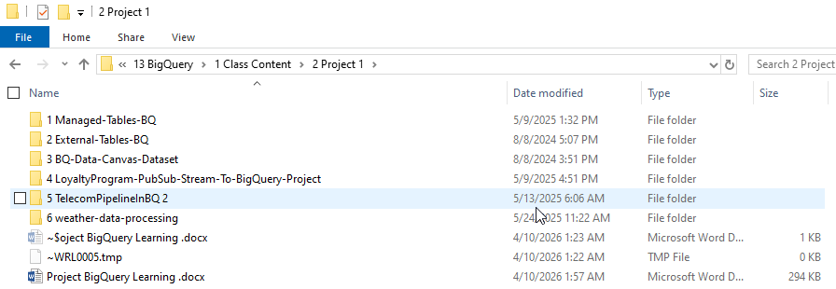

Managed Table:
Uses commands.sql, scheduled_query.sql, and the telecom CSV. It creates a dataset telecom_db,
loads CSV data from Google Cloud Storage into a native BigQuery table, then creates a daily summary
table and a scheduled aggregation query.
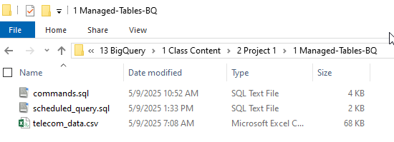

External Table:
Uses create_bq_external_table.sql plus the JSON ride files. It creates a BigQuery dataset lyft_db
and an external table over JSON files stored in Google Cloud Storage at gs://bigquery-data-gds/raw/date=*.
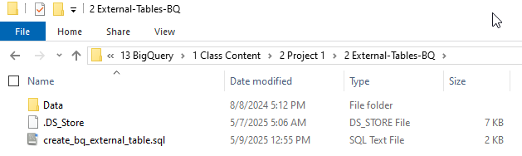
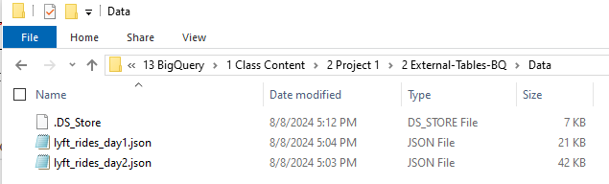

BQ-Data-Canvas-Dataset:
I have two csv files called: starbucks_customers.csv, starbucks_transaction.csv
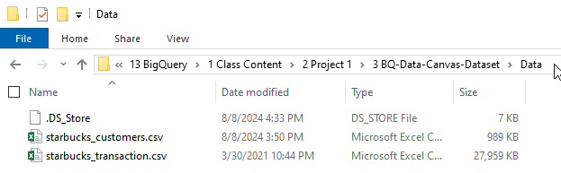

LoyaltyProgram-PubSub-Stream-To-BigQuery-Project:
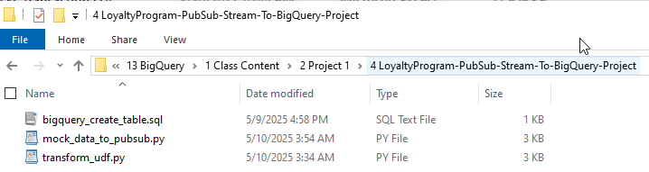
What it does (end-to-end flow): Python → Pub/Sub → Dataflow (transform) → BigQuery
Step-by-step components
1. Data generator (Python)
📄 File: mock_data_to_pubsub.py
Generates fake customer data
Sends it to Pub/Sub topic
👉 This simulates real-time events

2. Transformation logic
📄 File: transform_udf.py
Cleans data (email lowercase, name formatting)
Adds new fields:
loyalty_status
account_age_days
Fixes timestamps
👉 This is used inside Dataflow (stream processing)

3. BigQuery table (final destination)
📄 File: bigquery_create_table.sql
Defines schema for processed data
Stores clean + enriched records

TelecomPipelineInBQ 2:
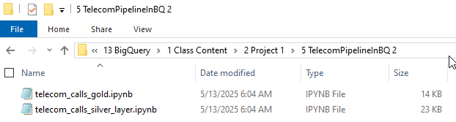
This folder is a data pipeline project using the Medallion Architecture:
RAW → SILVER → GOLD
📂 Files inside your folder
1 telecom_calls_silver_layer.ipynb

👉 Purpose: Clean & prepare data

What it does:
Reads raw telecom data
Cleans it:
Fix null values
Format columns
Standardize data types
Applies transformations
Outputs cleaned dataset (Silver table)

👉 Think of it as:
✔ Data cleaning
✔ Data validation
✔ Basic transformations

2️ telecom_calls_gold.ipynb

👉 Purpose: Business-level analytics

What it does:
Reads Silver data
Creates:
Aggregations (calls per user, revenue, etc.)
KPIs (usage, trends)
Outputs final analytics tables (Gold layer)

👉 Think of it as:
✔ Business insights
✔ Dashboard-ready data
✔ Aggregated metrics

RAW DATA (CSV / source)
↓
SILVER (cleaned data) ← telecom_calls_silver_layer.ipynb
↓
GOLD (aggregated insights) ← telecom_calls_gold.ipynb

weather-data-processing:
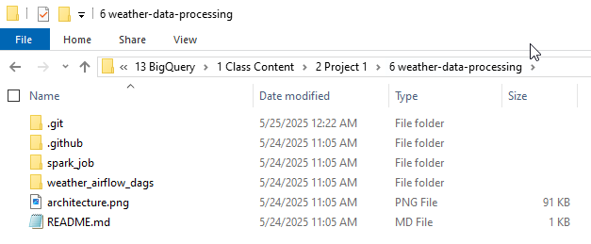
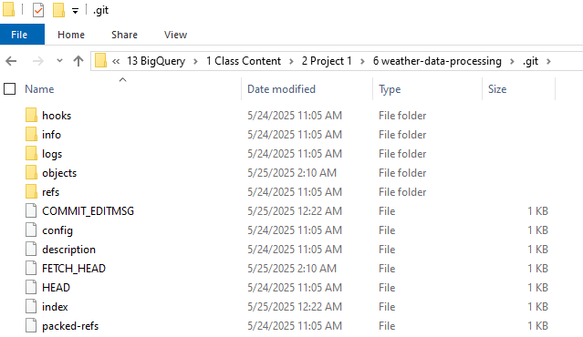
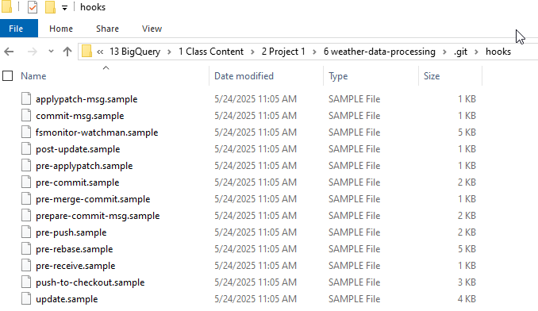
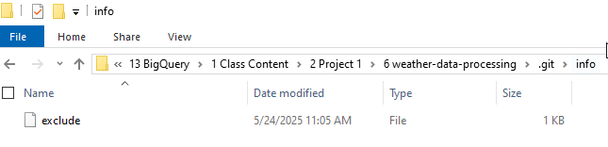
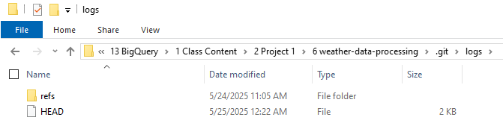
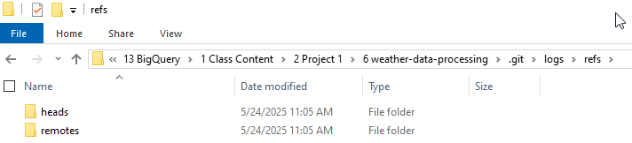
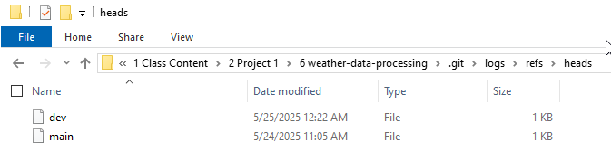
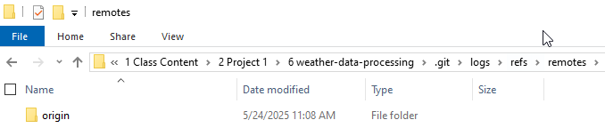
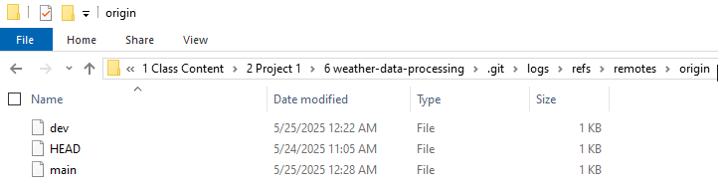
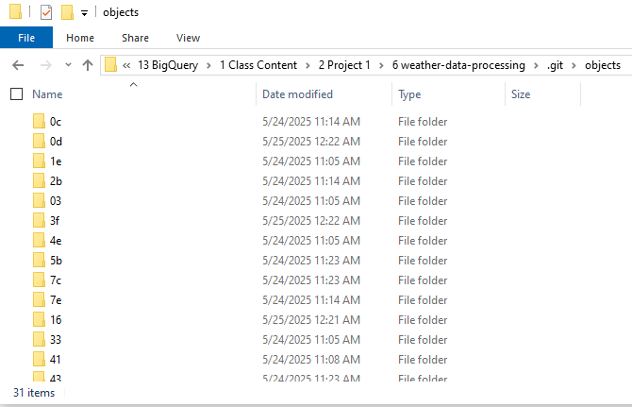
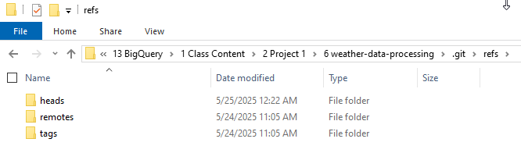
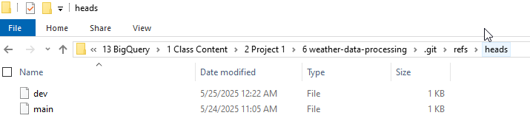
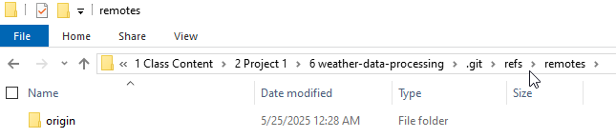
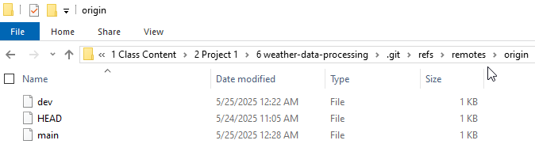
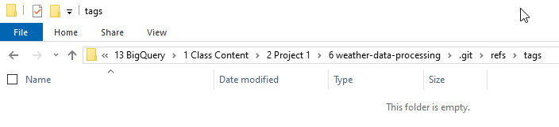
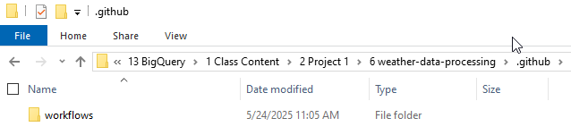
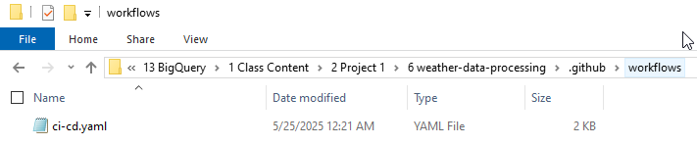
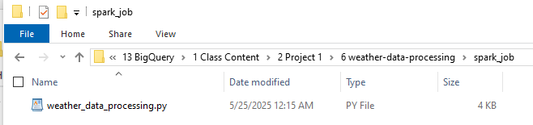
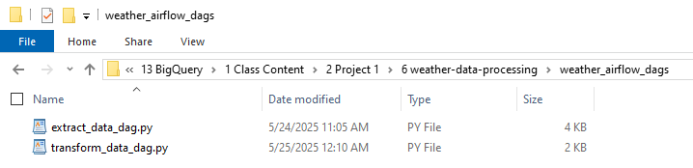
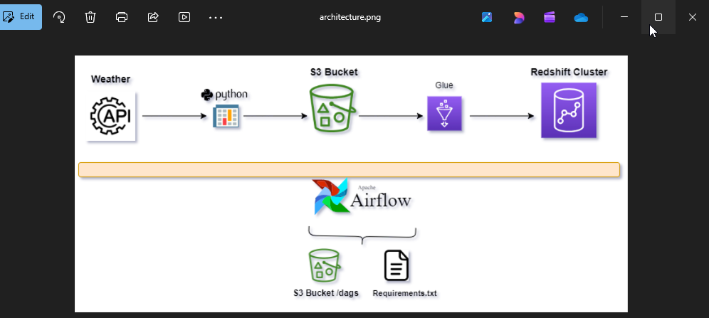
Final Question to ChatGPT:
I’m uploading the Project folder screenshot and a screenshot on what’s in every folder.
Tell me the execution order, step by step execution of the Project, the step by step GUI execution of the project, where should I upload the different files, what are the Tech Tools that I need to use. The following is the files that I’m going to upload into ChatGPT.
Files to upload:
Managed Tables:
Commands.sql and scheduled_query.sql
External Tables:
create_bq_external_table.sql
BQ-Data-Canvas-Dataset:
Nothing here.
LoyaltyProgram-PubSub-Stream-To-BigQuery-Project:
bigquery_create_table.sql, mock_data_to_pubsub.py and transform_udf.py
TelecomPipelineInBQ 2:
telecom_calls_gold.ipynb and telecom_calls_silver_layer.ipynb
weather_data_processing:
Inside the GitHub/Workflow folder: ci-cd.yaml
Spark job: weather_data_processing.py
Weather_airflow_dags: extract_data_dag.py and transform_data_dag.py
The Architecture picture

